

RESOURCE CENTER

for Texas Association of Charitable Clinics (TXACC)

By MAVDEV

Ammar Lokhandwala

Maria Frausto Michael Gurch Victoria Sheraden

Vivian Bui

MIS 374 – Business Systems Developer

Spring 2022

Page 0

# Table of Contents

Executive Summary 2

1. Resource Center Overview 3
   1. Model As-Is Client Situation 3
   2. Root Cause Analysis for TXACC – Resource Center 5
   3. To Be Concept Diagram for TXACC – Resource Center 7
   4. Additional To-Be Models [OPTIONAL] 8
   5. User Stories for TXACC – Resource Center 9
   6. Non-functional Requirements for TXACC 22
   7. Feasibility Matrix 24
   8. Project Risk Evaluation & Risk Reduction Strategies [OPTIONAL] 25

1.9 System Evaluation Table and Budgets 28

1. Resource Center Sprint Planning 30
   1. Planning Strategy 30
   2. High-level Project Timeline 32
   3. Trello Board – User Stories (electronic access provided to professor) 33
2. Appendices 34
   1. TXACC Background and Overview 34
   2. TXACC Organization Chart [OPTIONAL] 34
   3. Stakeholders Analysis for Resource Center 35
   4. Empathy Map for TXACC [OPTIONAL] 40
   5. System Architecture Review Checklist [OPTIONAL] 40
   6. To Be Systems Architecture [OPTIONAL] 43
   7. Sample Input / Output Documents/Sample Data from Client [OPTIONAL] 44
   8. Prototype Iterations 44

3.9 Client Meeting Agendas 44

Executive Summary

Dear Joe Saceric and Umera Khan,

**Overview**

The Resource Center project was initiated as an effort of TXACC to create a communication and training platform where clinic members of TXACC can access learning materials and collaborative tool kits such as working templates, discussion room, group chat, surveys, polls, live videos, how-to-guides, and presentations. The leadership team of TXACC believes the Resource Center to be a vital platform that helps fulfill the organization’s main mission of ensuring their statewide network of charitable clinics has adequate tools and skillsets to continue providing high-quality and low-cost care to underserved Texans.

**Problem Statement**

After discussions, we determined that TXACC’s current platform, Google Groups, was not meeting the organization’s requirements for the Resource Center due to its difficult UI system and the lack of a centralized document library with a search and filter tool. Furthermore, in terms of communication, Google Group falls short in the ability to create group chats and notify users of news and updates in a timely manner. Due to these shortcomings of Google Groups, TXACC clinics faced difficulties in navigating resources and were unable to work together effectively. A new platform, thus, is needed for (1) training purposes and (2) communication.

**Proposed Solution**

**Objectives**

As a result, our solutions are broken down into two parts: (1) a communication platform that enables information sharing between clinics, and (2) a content management system to store information that can be organized, sorted, and searched with an easy UI. We identify Mighty Network to be the platform that fulfills all the stakeholders’ requirements and chose this to be our proposed system. Mighty Network allows direct interaction between clinics through its groups and chat rooms functionalities, while simultaneously providing the search tool and push notifications to users for new updates.

**Constraints**

Considering that we are only allowed to have 12 weeks to complete the project while there are many functionalities required for the new system, time and limitation of scope are identified as our major constraints. Simultaneously, the variation in the technical skills of each user within TXACC and TXACC’s network of more than 70 clinics leads to the fact that technical maintenance and the organizations’ resistance to change are the constraints we need to be aware of when building the platform.

**Risks and Reduction Strategy**

The major risks for this project are that it affects multiple business areas and there is a general lack of technical experience. The two main users of this system are the 70 clinics and the upper-management team. Since it affects both of these areas, we created a Google Form for clinic members and have weekly meetings with upper management to ensure the system will be implemented effectively. We plan on creating detailed users guidelines and conducting comprehensive training sessions to ensure the best user experience for the platform.

Best Regards,

Team MAVDEV

Vivian Bui, Maria Frausto, Victoria Sheraden, Michael Gurch, Ammar Lokhandwala

Page 2

# TXACC – Resource Center Overview

## Model As-Is Client Situation

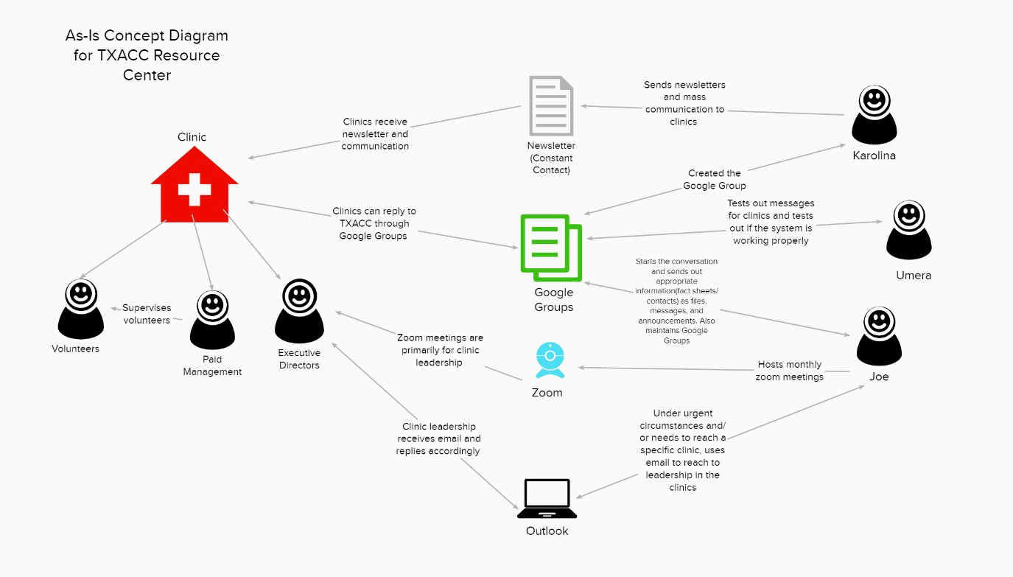

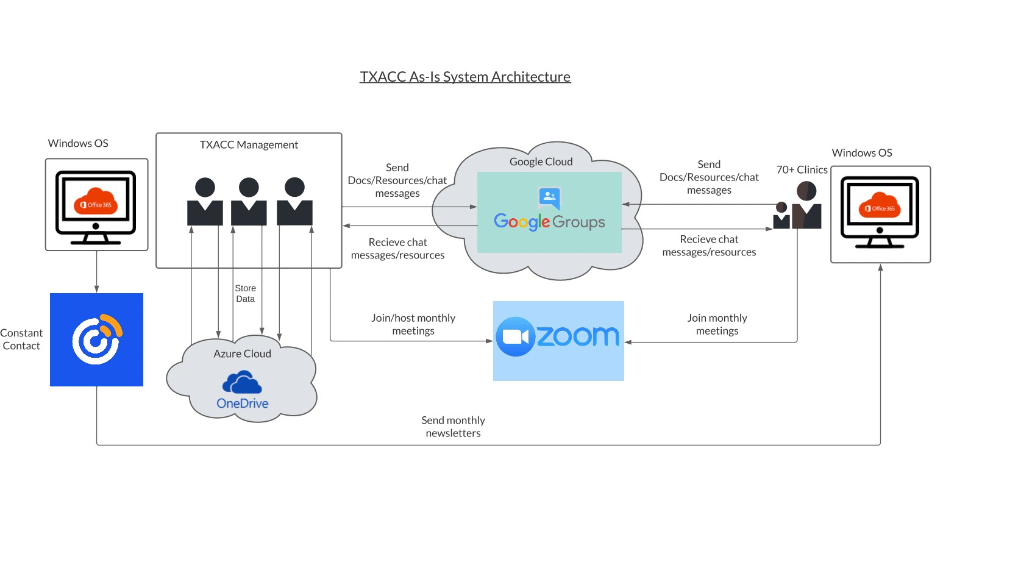

Page 3

* + 1. **Where do you need clarity the most? Make sure you’re modeling the current state of whatever needs clarity (e.g. as-is system, as-is process, as-is web-flow, etc...).**
* From a system architecture standpoint, the area we need clarity in the most is the current systems TXACC uses to communicate with its clinic members.
* The area we need clarity in the most from a business process standpoint is how information and documents flow between TXACC and the clinic members. There are multiple platforms that TXACC utilizes, so we need clarity if there is any interaction or crossover between these systems. With this in mind, a concept diagram was the best choice to model choice as it displays the software, people, and processes that took place and helped get clarity.
  + 1. **What insights from this model do you think are going to be relevant to your root cause analysis and/or a potential solution?**
* The biggest insight from the as-is model is that Google Groups is not a sustainable communication system for connecting with clinics and delivering information to volunteers. Some problems cannot be addressed because clinics do not understand messages or ignore them. The UI is confusing for users and needs to be updated.
* From the system-architecture standpoint, the most relevant insight for us was how the executive director and Resource Center manager communicates with all 70 of the clinics. The current systems used are repetitive, tedious, not user-friendly. These issues are addressed in our root cause analysis.

Page 4

## Root Cause Analysis for TXACC – Resource Center

### Section 1. Problem Chain

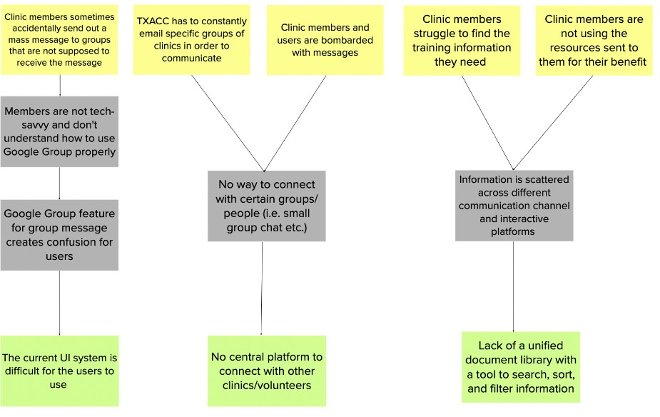

**Section 2. Summary of Potential Solution(s)**

1. Utilize a communication platform that unifies the communication pipelines and information sharing process between TXACC and clinic members.
2. Utilize a CMS to store information that can be easily organized, updated, sorted, and searched with an engaging and easy-to-navigate UI/UX.

### Section 3a. Solution 1 (Unified Communication Facilitator)

* Objectives for Solution 1
  + The platform must instantly notify users of new messages, mass announcements, and updates.
  + Clinics can communicate directly with other specific clinics.
  + Ability to manage access, data control, and grant privileges to certain users.
  + It has the ability to add new features like tiered-access and BLANK and expand members when needed.
* Measurable Performance Criteria for Solution 1
  + 4 out of 5 users should be able to locate and properly use the communication tool by sharing information to TXACC and an individual clinic accordingly.
  + Notifications of new messages and updates should be received by the end-user in less than 10 seconds.
  + All users should be able to access the system on their desktops.
  + 4 out of 5 users should be able to properly use 90% of group features without consulting the user guide.
  + Admin (Joe or Umera) can grant privileges to certain users 95% of the time.
  + Open beta surveys must show that more than 75% of users feel comfortable and more engaging with the new communication platform.

Page 5

### Section 3b. Solution 2 (CMS)

* Objectives for Solution 2
  + Information can be categorized and organized by topics and groups.
  + There must be a search engine that can sort, filter, and lookup documents based on names and uploaded dates.
  + Information can be updated or deleted by admins.
  + Updates must be visible instantly for users.
  + There must be distinct user access.
  + UI/UX Design must be engaging, user-friendly, and help ease the process of navigating information.
  + Clinics can request to upload files themselves to the resource center
  + The IT team receives an IT issue and can solve the issue for the clinic through the resource center.
* Measurable Performance Criteria for Solution 2
  + Information can be split into 5 topics.
  + The search delivers correct results in 15 seconds or less
  + The 2 users in administrative roles will be able to edit information in the 5 categories.
  + Users can see new updates to the system within 5 minutes of updates
  + 90% of the volunteers can log in successfully daily.
  + All volunteers are able to navigate the system and find information on a particular topic in 3 minutes.
  + Umera and Joe can receive and approve the file within two days for clinic upload.
  + The IT team can receive the issue and successfully fix it within a day

### Section 4. Constraints

* Constraints for all Solutions
  + **Budgetary Constraints:** There is currently no budget for this project. We will research different solutions and make cost projections to help Joe establish an official budget for us
  + **Limited Scope:** This system needs to be created and delivered to the 70 clinics in the TXACC system. There are lots of features the client wants in this system. We will utilize the prioritization (aka the feasibility matrix) to determine which features are high priorities for our client. We will also try to deploy to a few clinics at a time.
  + **Time Constraints:** There is limited time to complete the project, as the MIS374 team will only be working on it for a semester. We will utilize the agile project planning methodology to use these 12 weeks effectively.
  + **Technical Maintenance:** The system will need to be maintained by someone who is not as experienced with IT. We will utilize co-creation, user guidelines, and personal workshops to help Umera inherit and learn about the platform as much as possible.
  + **Resistance to Change:** Organization denies adapting to the systems and/or having difficulties in implementing the new system. To combat this, we will create training materials and user guidelines to help volunteers transition to the new process.

Page 6

## To Be Concept Diagram for TXACC – Resource Center

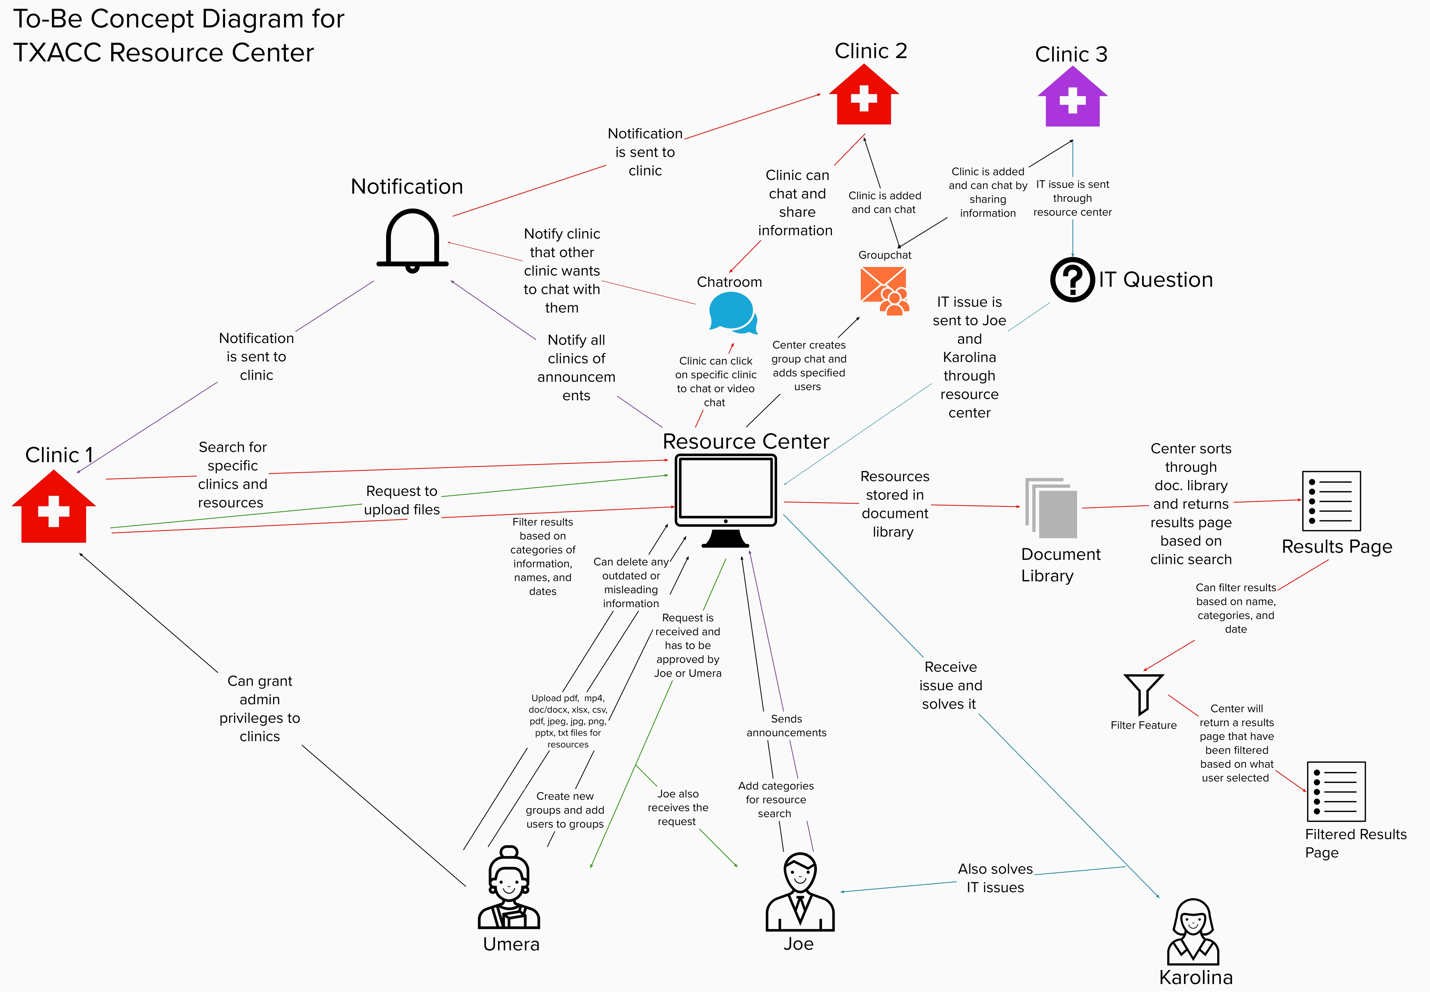

Page 7

* 1. ***Additional To-Be Models [OPTIONAL]***

This section is omitted since (1) the concept diagram is sufficient to depict the general prospective business process and (2) we want to be open and flexible in how the business process and data will flow on the platform as we aim to use plugins/ built-in features of the cloud-based packaged solutions, meaning that we will not have much customization in the process.

Page 8

## User Stories for TXACC – Resource Center

|  |  |  |
| --- | --- | --- |
| **User Stories** | **Functional Components & Features** | **User Acceptance Criteria** |
| 1. I, Umera Khan, as the person in charge of maintaining the Resource Center would like to **upload files** (mp4, doc/docx, xlsx, csv, pdf, jpeg, jpg, png, pptx, txt) to the Resource Center so that the clinic members can get the training materials needed for their services. | **Must**   * Have an edit button to manage documents, chats, and categories. * Be able to accept all file forms listed on the left * Update user interface to reflect the new information * Have an option to upload the file under a certain category for organization purposes   **Should**   * Create a textbox to allow users to provide a description of file being uploaded   **Could**   * Create an automated process to upload files | * Display screen to upload files * Upload all the file types successfully (mp4, doc/docx, xlsx, csv, pdf, jpeg, jpg, png, pptx, txt) * Uploaded files are visible and accessible for clinic members |

Page 9

|  |  |  |
| --- | --- | --- |
| **User Stories** | **Functional Components & Features** | **User Acceptance Criteria** |
| 2. I, Umera Khan, as the person in maintaining the Resource Center would like to **approve files** that clinic members request to upload to the Resource Center so that TXACC can ensure and control the quality of uploaded materials for members’ usage. | **Must**   * Send approval request to user after a file is submitted * Be able to view the files that are submitted * Be able to edit the files that are submitted * Be able to store the file into the document library once it’s approve * Have an “Approve” or “Not Approve” button on the screen   **Should**   * Have the ability to return the document for edits by original clinic * Create a textbox to allow user for an optional explanation of why a file was not approved * Be able to download the files that are submitted * Be able to see a version history for files   **Could**   * Create a feature that would do this automatically | * Display screen to approve files * View files that are submitted * Approve files that are submitted |

Page 10

|  |  |  |
| --- | --- | --- |
| **User Stories** | **Functional Components & Features** | **User Acceptance Criteria** |
| 3. I, Umera Khan, as the person maintaining the Resource Center would like to **grant privileges and assign users to different roles** so that I can have different levels of access in the Resource Center. | **Must**   * Have a clear guideline of all possible roles and their related privileges * Create a page that admin can add, edit, or delete a member from/in a role * Have an “Add User” button to start the process of assigning users to roles * Have a “Confirm” button * Notify users once they are assigned a role * Create an area where users can maintain/edit their profile * Create a login page * Create a membership list   **Should**   * Have a large button to indicate the login page * Members are able to contact each other through chat rooms and through their profiles   **Could**   * Have a search bar to search for specific users that can be assigned to a role * Display all roles in a drop-down list * Be able to filter members by roles   **Won’t**   * Define rules to automatically assign users to a role based on a certain attribute * Users can see other users’ roles | * Receive clear guidance on all possible roles and privileges in the system * Add a clinic member to a specified role * Edit/fire a clinic member from a specified role * Users are able to check their role |

Page 11

|  |  |  |
| --- | --- | --- |
| **User Stories** | **Functional Components & Features** | **User Acceptance Criteria** |
| 4. I, Umera Khan, as the person in charge of maintaining the Resource Center would like to **create new groups and add users to groups** so that clinic members can interact and share information with specified users. | **Must**   * Have a “Create” button to start creating the group chat * Have a search bar to search for specific users * Have a “Add User” button to add user to the group chat * Have a textbox to name the group chat   **Should**   * Have an option to preview a user’s profile information * Have an option to remove users from chat * Have a textbox to include an optional description of the group chat   **Could**   * Have an option to specify rules in a group chat | * Display screen to create a group chat * Can create a group chat with specified users * Can select users and add to chat |

Page 12

|  |  |  |
| --- | --- | --- |
| **User Stories** | **Functional Components & Features** | **User Acceptance Criteria** |
| 5. I, Joe Saceric, as the executive director of TXACC would like the platform to **send notifications automatically** to users for updates made so that all clinics and system users will stay up-to-date on new materials, updates, and announcements made via the platform. | **Must**   * Notify the user immediately about new materials updated through email * Notify the user immediately about the new mass announcement * Notify the user immediately about new direct messages received through the platform * Notify the user immediately about new group messages received through the platform   **Should**   * Users have the option to turn on/off the notifications for a certain amount of time * Admins can exclude certain individuals from receiving notifications   **Could**   * Show which users are muting their notifications * Users can be notified through regular SMS messages (additional rates may be applied) * Users are notified through their devices other than desktop (I.e., phone, tablet) without the need to access a web browser   **Won’t**   * Show numbers of people who have read the message * Notify the admins of whom has viewed the notification * Notification will be sent as a voice message to the users | * Notifications are visible on users’ devices * Can receive notifications for new materials uploaded to the platform * Can receive notification about edits made on the documents/ training materials * Can receive notifications of new announcement * Can receive notifications of direct messages specified to user * Can receive notification of group chat user is a part of |

Page 13

|  |  |  |
| --- | --- | --- |
| **User Stories** | **Functional Components & Features** | **User Acceptance Criteria** |
| 6. I, Joe Saceric, as the executive director of TXACC would like to **send mass announcements** so that I can avoid repeating the same information and keep my clinics up-to-date. | **Must**   * Have a form and view created for sending out the mass announcement * Mass announcements are visible to all users of the platform * Mass announcements are readable and accessible on tablets and/or mobiles through application and email   **Should**   * Senders can exclude certain individuals from seeing mass announcements * Have a storing/archiving place for all past announcements   **Could**   * Mass announcement is a two-way communication: receivers can reply back to the announcement * Mass announcements can be sent and received through SMS messages (additional rates may be applied) * Mass announcements are created by devices other than desktop (I.e., phone, tablet) * Admins can set up a time for when the announcement will be sent out * Announcements are editable and users can see if changes have been made to the announcement   **Won’t**   * Announcements are editable after sending out * Senders can set up recurring announcements that automatically send and notify users | * Display a screen to send announcements * Can send an announcement * Announcements are visible to receivers * Announcements are received through application * Announcements can be received/viewed through email |

Page 14

|  |  |  |
| --- | --- | --- |
| **User Stories** | **Functional Components & Features** | **User Acceptance Criteria** |
| 7. I, Joe Saceric, as the executive director of TXACC would like to **add categories** to the Resource Center so that files are organized by topics and clinics can quickly find the information they need. | **Must**   * Have a button to add and edit categories * Change the displaying order of categories * Naming control – only allow users to enter new categories’ names that have not been used, and users need to follow certain rules and only allow certain characters in naming * Admins can specify who can access the newly added categories   **Should**   * Categories can be deleted (with a confirmation box to make sure users will not delete by accident) * Data from deleted categories is backup and can be restored   **Could**   * Name suggestions for newly added categories   **Won’t**   * Allow same categories name * Allow regular users to add categories (because this feature is admin only) | * Display screen to add or edit categories * Can add a category * Can edit a category * Cannot add a category with a name that has already been used |

Page 15

|  |  |  |
| --- | --- | --- |
| **User Stories** | **Functional Components & Features** | **User Acceptance Criteria** |
| 8. I, Karolina Rivera, as the person in charge of IT troubleshooting, would like to **receive IT questions** from clinics through the Resource Center so that I can solve the IT issues clinics are experiencing. | **Must**   * Display a list of all questions that have been received * Display a list of all questions that have been resolved * Have button to mark a question as “Resolved” * Display names and contact of the person who requested IT help * Be able to contact the person through the platform * IT questions can be viewed on the application * IT questions can be viewed from email notfication   **Should**   * Submitted questions are editable, and receivers will see both unedited and edited version * Send notification or email confirmation to the user when a question is marked “Solved”   **Could**   * Set up a storage/database/archiving place for all questions * Create a search function for both clinic members and the IT specialist to look up whether or not similar issues have been solved * Have a chatbot that automatically answers recurring questions * Have a page that displays a list of recurring questions with answers for clinic members to view   **Won’t**   * Allow other clinic members to see who recently sent a question to the IT team | * Display IT question, including: contents, names and contacts of the person who requested IT help * Can mark question as “Resolved” on the application |

Page 16

|  |  |  |
| --- | --- | --- |
| **User Stories** | **Functional Components & Features** | **User Acceptance Criteria** |
| 9. As a clinic member, I would like to **search for specific clinics** in the Resource Center so that I can cut down my time in navigating the contact information and communicate directly to a TXACC member or other clinic members. | **Must**   * Have a search bar that allows users to search for other clinic members * Have filters that categorize all clinic members based on different criteria (location, name, services, etc.) * Filters can search clinics based on what category was selected by the user * Have a large “Search” button   **Should**   * Have a type-as-you-go feature in search bar   **Could**   * Have a search history option/page * Type-as-you-go feature can auto-suggest based on the characters/strings the user types * Search page can display top-searched clinics or categories   **Won’t**   * Everyone can view each other’s search history | * Display screen with a search bar * Display screen with the categories added * Can search other clinic members |

Page 17

|  |  |  |
| --- | --- | --- |
| **User Stories** | **Functional Components & Features** | **User Acceptance Criteria** |
| 10. As a clinic member, I would like to **search for resources** so that I can find the information I need. | **Must**   * Have a search bar that allows users to search for resources * Have filters that categorize resources based on different criteria (type of file, topic, etc.) * Filters can search resources based on what category was selected by the user * Have a large “Search” button   **Should**   * Have a type-as-you-go-feature in search bar * Type-as-you-go feature can auto-suggest based on the characters/strings the user types   **Could**   * Display suggested resources based on user’s search history * Have a search history option/page   **Won’t**   * Everyone can view each other’s search history | * Display screen with a search bar * Display screen with the categories added * Can filter results based on name, date, and category that was added by the admin |

Page 18

|  |  |  |
| --- | --- | --- |
| **User Stories** | **Functional Components & Features** | **User Acceptance Criteria** |
| 11. As a clinic member, I would like to send a **request to upload files as resources** so that I can share my training resource with other clinics. | **Must**   * Display a screen that enables users to input their file * Have a confirmation page once the file was successfully sent for approval * Have error messages when file could not be sent for approval * Have a large “Upload for Approval” button * Have a large “Choose File” button   **Should**   * Have a textbox that allows users to provide an optional description of the file selected * Notify user if file was approved or not approved * Be able to view comments from the user that did or did not approve file   **Could**   * Be able to view submission file after it was sent for approval * Log-in feature | * Display screen to upload file for approval * Send request after uploading file * Display confirmation page once file was sent for approval |

Page 19

|  |  |  |
| --- | --- | --- |
| **User Stories** | **Functional Components & Features** | **User Acceptance Criteria** |
| 12. As a clinic member, I would like to **open a chatroom and send a chat to the clinic** I searched up so that I can communicate with TXACC and other clinic members. | **Must**   * Display a screen with all the chatrooms that the user is a part of * Have a textbox for users to input their messages * Have the option for a direct message * Have the option for a group chat * Have a “Send” button * Have an option to send videos, images, or documents (mp4, doc/docx, xlsx, csv, pdf, jpeg, jpg, png, pptx, txt)   **Should**   * Have a “Chat” button next to clinic when searching   **Could**   * Have a read receipt in chats * Have a last seen feature in chats * Indicate if user is online or not * Have the ability to see all past sent attachments * Have a contact information page with other messaging options (phone, email, address)   **Won’t**   * Have a “Unsend” button to unsend or delete messages | * Display screen for all chatrooms * Send and receive message directly to/from clinic/group * Send any kind of attachment to a clinic |

Page 20

|  |  |  |
| --- | --- | --- |
| **User Stories** | **Functional Components & Features** | **User Acceptance Criteria** |
| 13. As a clinic member, I would like to **request for IT help and send a question** through the Resource Center so that I can quickly communicate to TXACC that there is an IT issue. | **Must**   * Have a large “Report an IT Issue” button * Display a screen that allows users to enter their problem into a textbox * Have a confirmation page once the IT issue was successfully reported * Have a large “Send Report” button   **Should**   * Notify user about IT report status (pending/solved) * Be able to view any comments from the IT Team about the issue   **Could**   * View history of IT reports | * Display screen to send IT Report * Display confirmation page once IT issue is reported |

Page 21

## Non-functional Requirements for TXACC – Resource Center

* + 1. **Maintainability** -- Joe Saceric and Karolina Rivera will be the IT specialists for the resource center since they have IT experience and knowledge. Both have their set of responsibilities as Joe is the Executive Director and Karolina is the Program Services Manager of TXACC. The system should be easy to maintain and have a friendly back-end user interface.

|  |  |  |
| --- | --- | --- |
| **Requirement** | **Priority** | **Project/User Story** |
| Provide thorough documentation and create a developer reference guide that Joe and Karolina can use to troubleshoot common issues | Must Have | Project |
| Back-end user interface must be easy to use and navigate through | Must Have | User Story 9 |
| Joe and Karolina can maintain the system with their general IT experience and knowledge | Must Have | Project |
| System can provide automated updates so that Joe and Karolina don’t have to do it manually | Should Have | User Story 1 |

* + 1. **Portability --** About 2500+ users will mostly access the system through work desktops/laptops and major browsers (Google Chrome, Microsoft Edge, Mozilla Firefox, Safari). The system should also have the potential to be accessed through mobile devices in the future if needed.

|  |  |  |
| --- | --- | --- |
| **Requirement** | **Priority** | **Project/User Story** |
| System will be compatible with the major browsers (Chrome, Edge, Firefox, etc.) | Must Have | Project |
| User interface must be optimized for Window PCs and Mac | Must Have | Project |
| System can be accessed on mobile devices (Android, iOS) through browsers | Should Have | Project |

* + 1. **Scalability –** The TXACC Resource Center hopes to maintain their current 70 clinics (small, medium, and large). Joe Saceric has identified 6 clinics to be beta testers and hopes to create a tiered-access system sometime in the future. Additionally, they hope to grow 10-15% over the next 3 years.

|  |  |  |
| --- | --- | --- |
| **Requirement** | **Priority** | **Project/User Story** |
| Data storage for the centralized document library can increase in size by 15% in 3 years. | Should Have | Project |
| The central document library can accommodate for the growth of 15% of users. (Currently will serve 2500-3000 users) | Should Have | Project |

* + 1. **Security** -- The TXACC Resource Center stores employees and important clinic information. Therefore, it’s important to only allow access to members with logins and limit their access based on their assigned roles. In addition, the document library is meant primarily for internal use only.

|  |  |  |
| --- | --- | --- |
| **Requirement** | **Priority** | **Project/User Story** |
| Access is only granted to those with logins | Must Have | User Story 3 |
| The document library is used internally | Must Have | Project |
| The system uses role-based access to provide access to authorized users | Must Have | User Story 3 |
| TXACC offers a tiered system for potential external users | Could Have | User Story 3 |

Page 22

* + 1. **Performance** -- Clinics have issues finding information pertaining to their clinic and fundraising documents. Clinics currently use GoogleGroups as their primary way of contacting each other, but this system makes it difficult for them to find the right information. It would be nice if TXACC could communicate effectively to all 70

of their clinics through a new system.

|  |  |  |  |
| --- | --- | --- | --- |
| **Requirement** | **Priority** | **Project/User Story** | |
| Clinics can find relevant information within one minute | Must Have | User Story 11 | |
| It takes an average of 5 minutes to reflect any updates within the system | Must Have | User Story 1 | |
| Documents can be retrieved in less than 3 minutes | Must Have | User Story 11 | |
| Notifications of new messages and updates should be received by the end-user in less than 10 seconds. | Should Have | User Story 5 | |
| Clinics are able to chat and reply to messages as soon as they receive them | Should Have | User Story 13 |

* + 1. **Accessibility** – There are currently no known employees or clinic members that require ADA accommodation. TXACC upper management has about 8 members who primarily use English. However, as TXACC expands, we can consider adding options for multiple languages.

|  |  |  |
| --- | --- | --- |
| **Requirement** | **Priority** | **Project/User Story** |
| English language used for the system | Must Have | Project |
| Add other languages/translator function | Could Have | Project |
| ADA accommodations for those who are visually/hearing impaired | Won’t Have | Project |

Page 23

## Feasibility Matrix

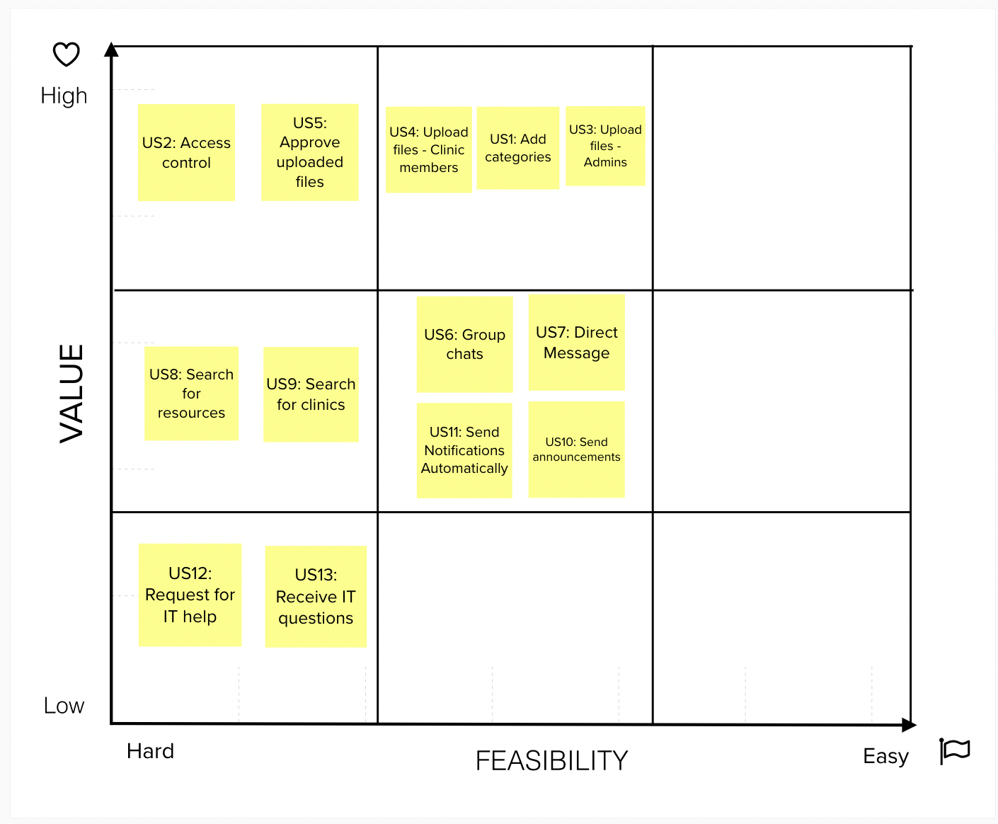

Page 24

* 1. ***Project Risk Evaluation & Risk Reduction Strategies***

|  |  |  |  |
| --- | --- | --- | --- |
| **Factors affecting project risk** | **Rating \*** | **Comments** | **Risk Reduction Strategy** (n/a if not relevant) |
| **1. Characteristics of the organization**  a. Has stable, well-defined objectives? | +1 | TXACC provides trainings, resources, and advocacy to this broad network of charitable clinics ensuring they have the tools to provide the best care possible to those who need it most. | N/A |
| b. Does TXACC have an existing IT Team and/or budget for IT? | 0 | Is there a designated budget for IT? | N/A |
| c. Does proposed system fit strategic plan and address TXACC’s objectives? | +1 | The proposed system will allow TXACC to share trainings and resources to help clinics with their services. | N/A |
| d. Does executive sponsor of the proposed system have adequate authority to fund project scope? | +1 | Joe Saceric has authority to approve budget. | N/A |
| e. Does TXACC experience a low rate of turnover? | 0 | How often do new volunteers come in to TXACC?  How long do executive directors remain in their position?  Where do you see TXACC in 5 years? Are you still involved? | N/A |
| **2. Characteristics of the information system**  a. Model available/clear requirements? | +1 | TXACC has Google Groups, which helps us understand each stakeholder’s role and responsibilities for new proposed system | N/A |
| b. Are there existing/routine processes in place? | +1 | Yes, TXACC sends announcements and resources/trainings through Google Groups. They also send  a weekly newsletter through Constant Contact. | N/A |

Page 25

|  |  |  |  |
| --- | --- | --- | --- |
| **Factors affecting project risk** | **Rating \*** | **Comments** | **Risk Reduction Strategy**  (n/a if not relevant) |
| c. Does this system affect only one business area? (No cross-functional or interorganizational links?) | -1 | The proposed system will affect various business processes based on clinic. | Since multiple areas are affected, we need to gather information from the different areas like IT, upper- management, and clinic members. This will help with collaboration and ensuring the system is beneficial to everyone. |
| d. Can be completed in less than three months (a school semester)? | +1 | According to our Gantt chart, the project can be completed in less than three months. Additionally, most of our tasks can be done in a day or two, which allows us to dedicate a week for every sprint. | N/A |
| e. Uses stable, proven technology? | +1 | TXACC uses Google Groups, stores files in OneDrive, Zoom for monthly meetings, Constant Contact for newsletters, and WindowsOS for daily tasks. | N/A |
| f. Are we installing or deploy at only one site? | -1 | The proposed system will deploy in 70+ clinics across Texas. | Since we are not deploying at just one site, we plan on deploying in various stages. We will start with a small group of clinics (one of each size small, medium, large). |
| **3. Characteristics of the developers**  a. Are experienced in chosen development methodology (e.g. Agile, waterfall)? | 0 | Team is familiar with Agile principles from class, but it is their first time implementing the methodology in a project. | N/A |
| b. Are skilled at determining functional requirements? | +1 | Team is experienced and skilled in determining functional requirements from lectures, group project, and in-class exercises. | N/A |

Page 26

|  |  |  |  |
| --- | --- | --- | --- |
| **Factors affecting project risk** | **Rating \*** | **Comments** | **Risk Reduction Strategy**  (n/a if not relevant) |
| c. Are familiar with the chosen solution’s technology and information architecture? | 0 | Where can you find more information about the system? Are you able to do a demo of the system?  Has anyone written about it in the Knowledge Exchange? | N/A |
| **4a. Characteristics of the internal users**  a. Have business-area experience? | 0 | Have you worked on projects like this in the past?  How would you describe your business process?  How experiences are your clinics in business areas? | N/A |
| b. Have technical or development experience? | -1 | From our meetings, it has been determined that clinic members have a limited set of technical skills and experience. | We will conduct training and create detailed guides for each level of user. We will also walk the client through each document and the system itself. |
| c. Are committed to the project? | +1 | Joe and Umera have attended all meetings and constantly show enthusiasm and determination for the project. They always make sure to answer our questions as well. | N/A |
| **4b. Characteristics of the external users**  a. Have business-area experience? | 0 | Have you worked on projects like this in the past?  How would you describe your business process?  How experiences are you with TXACC? | N/A |
| b. Have development experience? (if applicable) | -1 | External users might know the basics of navigating through TXACC’s website, but not the proposed system. | We will conduct training and create a reference guide for external users. We can also include an FAQ page on the system. |
| c. Are committed to the project? | 0 | External users will be indifieerent to the resource center as it does not affect them. | N/A |
| **Total Points** | 5 | Medium | N/A |
| * + 1 = yes; 0= maybe; -1 = no |  |  |  |

Page 27

## System Evaluation Table and Budgets

### List of possible solution options initially considered (include at least 10):

* + Mighty Networks
  + Tribe
  + honeycommb
  + Hivebrite
  + Toucan Tech
  + Socio
  + Disciple
  + Wordpress
  + Chanty
  + Twist

**Client Decision:** Mighty Networks

|  |  |  |  |
| --- | --- | --- | --- |
|  | **Alternative 1**: Mighty Networks | **Alternative 2**: Wordpress | **Alternative 3**: Honeycommb |
| **Key Features** | * Can create courses for users to get trained on things * Can connect other users and manage them * NO LIMIT on number of members! * Group messaging/ DM/ notifications from hosts * Can livestream * Can post articles, posts, questions, polls, topics, total storage is limited to 50 GB for cheap tier * Paid Memberships * File Uploads | * Group Chat Plugin * Web Design Plugin * Membership Plugin * Cloud Storage Plugin * Intergrations * Web-Hosting | * Discussions and group chats * Custom onboarding * Newsfeed feature * Custom primary menu * Can upload files * Content Discovery * Live video chat * Hashtag system * Member list |

Page 28

|  |  |  |  |
| --- | --- | --- | --- |
|  | **Alternative 1**: Mighty Networks | **Alternative 2**: Wordpress | **Alternative 3**: Honeycommb |
| **Advantages** | * Unlimited members/ hosts/ moderators * Cloud based * Zoom integration * Easy UI | * Highly customizable * Low / no code * Meets all needs | * Awesome UI/UX * Very customizable * Lots of features |
| **Disadvantages** | * Small storage space, will cost more to add storage (Engagement boosts) * Some features locked behind paywall, but not be important? | * Longer Dev time * Harder to maintain * Scaling is costly | * TOO many features probably, which can be overwhelming * No numbers on storage limit/members limit |
| **Budget** | Implementation cost:   * N/A   Recurring cost:   * Community Plan - $33/month * Business Plan - $99/month | Implementation cost:   * N/A   Recurring cost:   * Business Plan - $300/yr * Atom Chat – $384/yr * Blue Host – $60/yr * Domain - $10/yr * Extra Pluggins - $300/yr | Implementation cost:   * N/A   Recurring cost:   * Web App - $89/month * Full Suite - $300/month |
| **Questions/Unknowns** | * What does it look like? * Why are there no pictures? | * Is CMS included? * Is it mobile-friendly? | * What are the limits of the system? * Are there additional costs for scaling? |

Page 29

# Sprint Planning

**2**

## Planning Strategy

### Team Role Assignments

* Business Analyst (Maria Frausto and Victoria Sheraden)
* Ensure the developing system aligns with the business requirement and processes
* Stay up-to-date on the business requirement and add/edit user stories where necessary
* Develop test cases to test each functionality
* Test features and user stories
* Communicate testing results to team members
* Analyze testing results and develop SWOT analysis for improvements
* Develop user materials, admin materials, and training guidelines for end-users
* Developer (Ammar Lockhandwala and Michael Gurch)
* Build the system
* Perform unit tests for each functionality and communicate test results with the team
* Implement feedback and debug where necessary
* Develop user materials and training guidelines for prospective admins/back-end users of the system
* Deploy and publish the finalized system
* Project Management (Vivian Bui)
* Communicate and keep Joe and Umera (TXACC) updated on the project’s progress
* Keep team members updated on stakeholders’ requirements and inform the team about occasions when new user stories are needed to be added/edited
* Manage and control the project timelines and deliverables
* Assist BAs and Developers in creating training materials and guidelines
* Assist developers in building functionality where applicable
* Test features and user stories
* Re-evaluate risks, schedule, and team priorities where needed
* Review all test cases, test results, and team deliverables
* Ensure the project is focused and executed as expected (i.e. managing scope)

### Student Team Meetings and Ceremonies

* 30-minute Check-in *(Every Monday at 5 PM on Zoom, every Tuesday at 10:30 AM on Zoom, every Friday at 3 PM on Zoom)*
* Members update on (1) What did they do, (2) What will they do, and (3) What’s blocking them
* PM informs about (1) team progress, (2) upcoming plans, and (3) clients’ new requirements (if any)
* Finalize agenda and complete prep work for a weekly client meeting on Tuesday morning
* Team Workday *(Every Tuesday and Thursday at 5 PM on campus)*
* Members update on (1) What did they do, (2) What will they do, and (3) What’s blocking them
* PM informs about (1) team progress, (2) upcoming plans, and (3) clients’ new requirements (if any)
* Members works on code, analysis, and user stories tasks and deliver results where applicable

**Student Team Communication** *(Outside of Meetings)*

* GroupMe
* For regular team communication
* Slack
* For interaction with Professor
* Trello
* For communication regarding user stories (ADCRD, tasks, testing, progress, etc.)

### Client Meetings and Ceremonies

* Weekly Client Meeting *(Every Tuesday at 9:30 – 10:30 AM and every Friday at 2:00 – 3:00 PM on Zoom)*
* Keep the client updated on the team’s progress, ask questions to clarify requirements, deliver testing results, and communicate to understand the clients’ requirements or feedbacks

Page 30

* Review and re-evaluate user stories’ priority and sprint schedule; adjust schedule and planning where needed

**Client Communication** *(Outside of Meetings)*

* Email
* For Zoom invitation, meeting agenda, meeting summary, and other documents delivery
* GroupMe
* For Zoom invitation, meeting agenda, meeting summary, and other documents delivery

### Typical Sprint Timeline

* Start day: will be varied due to the difference in the difficulty level of each user story
* End day: will be varied. However, most of the sprint’s end day will be on either Tuesday or Friday (during client weekly meetings)
* Sprint length: 5-7 days
* Sprint Logistics – How tasks are divided per features/user story per sprint:
  + 1. Analyze: (Time allowed: <1 day)
  + Team meets with clients to confirm the user stories’ priority (PM) and clarify requirements for construction (Developers)
  + BAs understand the clients’ user acceptance criteria and map out training needs
  + Clients notify us if there are any new features needed to add per-user story
    1. Design: (Time allowed: <1 day, can be completed in the same day with Analyze)
  + Developers and PM design materials/ requirements for construction (i.e. numbers of views, etc.)
  + BAs and PM outline test cases, and training materials
    1. Construction: (Time allowed: 2-3.5 days)
  + Developers build features, PM and BAs can help with building when needed while focusing on testing and developing user guidelines
    1. Review: (Time allowed: 1-1.5 days)
  + Clients review and provide feedback on the built features
  + Team provides test results, receives and implements feedbacks
  + Clients give permission to deploy
    1. Deployment: (Time allowed: < 1 day)
  + Team backups production and runs smoke test
  + PM communicates about updates on the system to the clients (every sprint) and other end-users (in the last sprint)
  + Developers provide training to admins of the prospective system, clients attend training and continue to provide feedback
  + BAs and PM provide training to other users of the system
  + Client and team decides for sprint closure
* Client Involvement:
* Actively communicate with PM about their needs for the system and provide feedback on the project schedule/ planning for each sprint
* Actively communicate to help developers clarify requirements and provide developers with resources needed for building the system
* Work with BAs to develop user acceptance criteria and test case
* Test the features and provide feedback
* Work with the team to develop user guidelines
* Test the guidelines and attend training sessions
* Provide feedback on the guidelines and training sessions
* Allow features to be deployed, decide sprint closure, and sign-off Trello board
* Sprint Adaptation: If our priorities of user stories change, then we will do the following:
  + Communicate to our client through our weekly meetings and email the change in user story priority
  + Hold internal team meetings to discuss how to adjust other user stories by changing the priority (length of time, tasks, owner of story/tasks)
  + Adjust Trello Board and Gantt Chart to reflect these changes
  + Send and communicate to the client of our adjusted documents to get feedback

Page 31

## High-level Project Timeline

Link to UT Box: <https://utexas.box.com/s/72kyzfbmgl2yl0ykiwwuzniy5s2yzdzz>

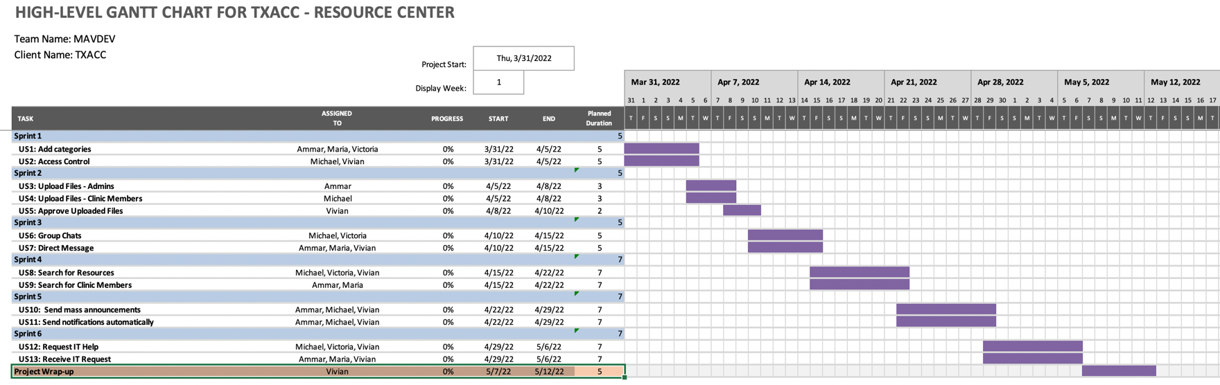

Page 32

## Trello Board – User Stories (electronic access provided to professor)

## 

### About work breakdown structure:

Each card on the User Stories Trello Board represents a single user story. Tasks will be assigned to team members initially depending on their project role. However, as we move forward in sprints roles may begin to overlap.

### How to mark completed work in Trello:

Within the Trello card there are checklists for each step in the ADCRD and a due date on the card for the final user story. Completed work will be evaluated in a team meeting at the end of the week with a checkbox for clients and the other members of the team.

### How to use Trello to manage testing:

Trello will be the go to planner for determining when tests will be and who will be in charge. If a user story card is moved to review, then we will know to begin testing.

### How to manage bug tracking and fixing in Trello:

For bug tracking and fixing, we will add additional tasks to cards to notify team members to fix any issues.

### How client sign-off on each feature completed:

The client “sign off” feature will be checked off in our Friday meetings with the client. We will go over the user story, have a Q&A session, and if there are no issues, have them sign off.

Page 33

# Appendices

## TXACC Background and Overview

## Background

## Texas Association of Charitable Clinics (TXACC) is a private, non-profit organization with a network of over 70 active charitable clinic members across the state who are currently providing healthcare for more than 300,000 underserved Texans. Through training, mentoring, education and advocacy efforts, TXACC aims to strengthen the charitable clinic system in Texas and ensure the best possible care received by Texans who utilize services from this network.

## The Resource Center

## The Resource Center, as a result, is part of TXACC’s efforts to ease the process of navigating resources for their clinic members and empower the conversations between members and TXACC’s leaders. The proposed Resource Center system will affect the organization in three main aspects: strategy, management, and operations.

1. **Strategic**

With the presence of the Resource Center, participating clinic members can easily get access to learning materials and collaborative tool kits including working templates, discussion room/ group chat, surveys/polls, live videos, how-to-guides, and presentations that connect the members’ conversations and enhance their skillsets in providing high-quality and low-cost care to the underserved Texans. The Resource Center will be a strategically vital platform that helps fulfill TXACC’s main mission of ensuring statewide charitable clinics across Texas have adequate tools for the best possible quality care to those who need it most.

2. **Management**

The leadership team and major prospective admins of the platform will find the Resource Center helpful in three major aspects: (1) Communication, Collaboration, and Engagement, (2) Efficiency, and (3) Productivity. Firstly, the online cloud-based collaborative tool kits with group discussion, chat room, and notification features will help effectively cut down the communication lag time between parties, promote cross-collaboration, and invite more engaging conversations between TXACC’s leaders and their clinic members. Secondly, a more organized cloud database with interactive categories and search functions will ease the process of information navigation and administrating training materials and members’ data. Finally, a more user-friendly UX/UI will increase the user experience and engagement with the platform which leads to an increase in productivity and performance of the management team.

**3.** **Operations**

The Resource Center will be the centralized database for all questions related to clinics’ training and guidelines where non-management members can visit and search for the information needed. This fastens the communication and operations across teams as information can be searched and issues can be quickly resolved through the platform. For end-users – or participating clinics – the platform will accelerate their communication with TXACC and other in-network members, ease their process of information navigation, and provide them with timely support and toolkits for better performance and experience of providing care.

Page 34

## TXACC Organization Chart

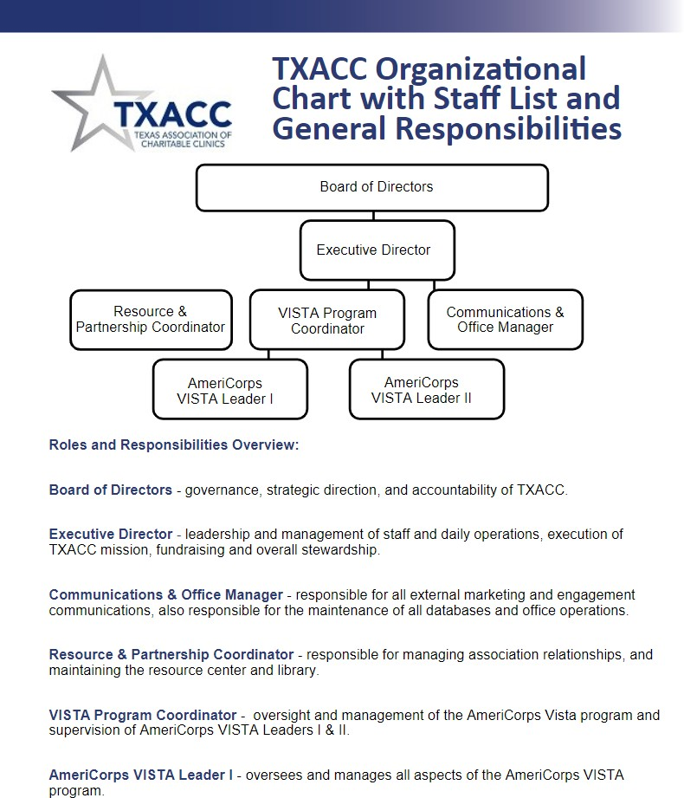

Page 35

* 1. ***Stakeholders Analysis for TXACC – Resource Center***

**User Community**

|  |  |  |  |
| --- | --- | --- | --- |
| **Role** | **Responsibility/ Function** | **Name** (if known) | **Comm. Objective** |
| Executive Director | Oversee daily operations, execute TXACC missions, lead fundraising, and overall stewardship. Define, monitor, and approve vision, goals, and budget for all TXACC projects and initiatives. | Joe Saceric | Gather information on vision, expectation, scope, budget, and key requirements of the project. Understand what TXACC hopes to achieve with the resource center (train volunteers, connect various clinics, etc). Understand how the resource center is going to be incorporated across the clinics. Reach out for review and approval of major project deliverables. Receive feedback from user testing. Notify feature and design updates, and provide user guidelines. |
| Resource & Partnership Coordinator | Manage TXACC relationships. Maintain the resource center/library. Act as the key point of contact between TXACC and clinics. | Umera Khan | Gather information about major TXACC members involved in the project and get the list of participating clinics. Understand the preferred prospective technology used for the backend system (i.e., document management tools and platforms). Understand if there are any special requirements for the future business process and architecture system. Reach out for review and approval of major project deliverables. Receive feedback from user testing. Notify updates. Deliver user training guide for post- project maintenance. |
| Communications & Office Manager | Handle and coordinate TXACC’s external marketing outreach to prospective clinics. Maintain engagement and communication with current clinics, donors, and across TXACC’s teams. Manage and maintain all TXACC databases and office operations/activities.  Manage the ConstantContact newsletters. Act as the key IT administrator and IT supporter of most TXACC’s major in-use technical tools and platforms. | Karolina Rivera | Understand the communication pipeline between TXACC and clinics and across teams. Gather detailed technical information about TXACC’s current data infrastructure, including how the current database is used, how the data is uploaded, sorted, and stored, as well as the types and the volume of data that will be transferred and connected to the prospective architecture system. Understand Karolina's experience, preference, and outlook for the prospective database. Consult the proposed database solutions to gain perspectives about its feasibility and maintainability for TXACC. Receive feedback from user testing. Notify updates, provide training, and deliver user guidelines for back-end developers and  administrators. |

Page 36

|  |  |  |  |
| --- | --- | --- | --- |
| **Role** | **Responsibility/ Function** | **Name** (if known) | **Comm. Objective** |
| Board of Directors | Govern major initiatives and provide strategic direction for TXACC. Held accountability of TXACC's operations and public representation. | N/A | N/A. The Board of Directors will not be involved in this project. The team does not need to contact per Joe's suggestion. |
| Volunteers at TXACC Clilnics | Work at various roles within a TXACC clinic. | N/A (Contact from list) | Understand the current business and architecture system at individual clinics. Understand the volunteers' general technical skills, their thoughts on the UI, and the overall number of volunteers will be interacting with the system. Notify updates. Provide training after deployment. Receive feedback from open beta after deployment. |
| Paid Managers at TXACC Clinics | Specific assigned function varies at each different clinic. For this project, we target the managers who have experience engaging with TXACC’s programs and platforms. For those, their responsibility generally includes collecting useful information from TXACC program coordinators and spreading this information to volunteers and patients. | N/A (Contact from list) | Understand the targeted clinic's organizational structure. Understand the clinics' general business process and architecture system. Understand the communication pipeline (i.e., how information is delivered) between the clinic and TXACC. Understand their perspectives about the Resource Center and their plan on using the Resource Center for management and training. Understand what UI they would prefer. Notify updates. Provide training after deployment. Receive feedback from open beta after deployment. |
| Executive Director for TXACC Clinics | Function varies at each clinic. Work directly with Joe to receive TXACC updates. | N/A (Contact from list) | Understand the current communication process between executive members and Joe, and between executive members and across their teams.  Understand the executives' perspective about the Resource Center and their plan on using the Resource Center for high-level management, team training, and knowledge sharing. Understand how to optimize the communication pipeline at the individual clinic level and between clinics versus TXACC using TXACC’s communication platform. Understand how to strengthen collaboration across clinics. Notify updates. Provide training after deployment. Receive feedback from open beta after deployment. |

Page 37

**Development Community**

|  |  |  |
| --- | --- | --- |
| **Role** | **Responsibility/ Function** | **Name** (if known) |
| Primary Contact/ Project Manager for TXACC/ Future Data Coordinator | Serve as the main point of contact between TXACC and MAV Dev. Main user tester. Clarify requirements. Approval throughout the project. Will manage data and information of the Resource Center once deployed, including organize, upload, and manage documents, as well as grant user roles and access for clinics. Will maintain the platform  and technology once deployed. | Umera Khan |
| Future IT Lead | Serve as the major source of information for technical questions for TXACC throughout the project. Main user tester. Provide feedback. Maintain and administer the back- end infrastructure after deployment. Grant roles and control access for other internal developers/administrators and clinics. | Joe Saceric and Karolina Rivera |
| Project Manager | Serve as the main point of contact between MAV Dev and TXACC. Communicate with the clients and help the team to stay on track with the project scope and timeline.  Monitor project triple constraints. Perform quality check on the team's deliverables. Assist team to create test cases during development.  Identify and control potential risks. Evaluate testing results for strategic planning. | Vivian Bui |

Page 38

|  |  |  |
| --- | --- | --- |
| **Role** | **Responsibility/ Function** | **Name** (if known) |
| Business Analyst (2) | Understand user requirements and manage client expectations.  Understand TXACC’s business processes and ensure the proposed system aligns with the business model. Assist developers in creating user guidelines and training.  Perform preliminary tests from a business/user perspective and provide feedback to developers during sprints. Deliver test results and perform SWOT analysis on test results to help management with planning and strategic decision- making. | Victoria Sheraden, Maria Frausto |
| Developer (2) | Understand the technical requirements and research on the best technical solutions for the client’s needs. Develop applications based on project requirements.  Develop user guidelines and training during each sprint. Test the system and implement feedback from user tests. Train clients in the technical aspects of the updated system. Develop system maintenance guidelines and provide training on system maintenance. | Ammar Lokhandwala, Michael Gurch |
| Instructor/Project Advisor | Provide helpful resources for the team's research of technical solutions. Consult and provide feedback on the team's deliverables  and development progress. | Clint Tuttle |

Page 39

## Empathy Map for TXACC [OPTIONAL]

The team decided to not go forward with an empathy map since our clients were forthcoming with their experiences and desires for the system.

## System Architecture Review Checklist [OPTIONAL]

This part is omitted since there is no existing system for the Resource Center.

|  |  |
| --- | --- |
| **Criteria for information gathering** | **Notes** |
| **1. General** | |
| a. Start with asking for an inventory of all the different systems used.  Tip: Have the client identify all the logins they have to use throughout the year. Also, ask about other tools that they use or locations of data they need to ensure you get a full inventory of systems.  Tip: Take note if any systems or parts of the system architecture has lost support or will lose support in the near future. |  |
| b. Which systems are **custom-built** and which are **COTS (i.e. Commercial Off-The-Shelf) software**?  Tip: COTS can include software the installed onsite or hosted SaaS software.  Tip: Are all products and services still under support? |  |
| **2. Hardware & Hosting** | |
| a. Where are systems hosted geographically? (e.g. On the client’s own onsite hardware? Are any housed on a hosting company’s servers or a SaaS provider’s servers) |  |
| b. Identify hosting package or tier of service the client is paying for. What are the features of this tier?  Tip: Take note what features they are using but also note features of their tier they are NOT using since this could be helpful as you map out solutions later.  Tip: See if client can create you an admin login for their systems so you can see what they use OR sit with them as they log into the system admin dashboard.  Tip: Custom systems may requiring talking to their IT Team that supports the system. For hosted solutions, details will be found in their billing. In many cases, its just as easy to call the host/saas company’s 800 phone support and ask what the client is paying for and currently utilizing. |  |

Page 40

|  |  |
| --- | --- |
| **Criteria for information gathering** | **Notes** |
| c. Are their IP addresses to servers that can be used for FTP access to the server? List them along with relevant directories  Tip: This is probably not relevant for SaaS solutions. For custom builds and hosted websites, this information can usually be accessed through the client’s hosting admin panel or cPanel. |  |
| d. Where are domains managed? How are they configured?  NOTE: Sometimes people buy their domain through their web hosting company but sometimes that purchase domains through one company (e.g.  GoDaddy) and forward the domain to the host of the website (e.g. BlueHost). Make sure the configuration is understood by calling the vendors if need be. |  |
| **3. Database Layer** | |
| a. Make a list of all data stores they use including digital (e.g. databases, google sheets) and non-digital (e.g. file cabinets) |  |
| b. What are names of databases? What are connection details (e.g. ip address or connection string, login credentials)  Tip: Note the capacity of their current databases and if they could be on track to run out of space. If so, note the cost to scale up to the next storage level. |  |
| c. Do applications or DBs communicate with each other? Does data flow between separate systems somehow?  Tip: In order to map out the system architecture, you’ll have to understand how the systems connect and communicate data between each other. Knowing this helps to create your system architecture model as well. |  |
| **4. Application Layer** | |
| a. Make a list of languages used.  Tip: Note any risks that could be associated with skillsets of developers |  |

Page 41

|  |  |
| --- | --- |
| **Criteria for information gathering** | **Notes** |
| b. Make a list of any add-ons, plugins or widgets being used?  NOTE: This typically only applies for CMS (e.g. Content Management Systems) like Wordpress and Squarespace. Some platforms like Salesforce allow you to activate add-on apps to expand the functionality of the base functionality.  Tip: Note the names these items and if they are being maintained by looking up the last time updates were released. What’s the rating of the plugins/widgets?  Tip: Note if the production system isn’t running the latest version of item |  |
| c. Are their important software tools used on desktops by users (e.g. Excel) or developers (e.g. Filezilla for FTP)  Tip: It’s good to know this early as you consider setting up environments and tools you’ll need to develop or test your sprints |  |
| **5. Presentation & Styling** | |
| a. Do applications use **custom** css styling or purchased/free **themes**?  Tip: Note the names of themes and if they are being maintained by looking up the last time updates were released. What’s the rating of the themes?  Tip: If CSS is custom, inquire if there is any documentation on css standards being used. |  |
| 6. Users | |
| a. What kind of devices are used to access the systems? (e.g. Desktops/laptops, Mac or PC, Tablets or mobile, browsers) |  |
| b. What is the geography of the users? (e.g. Single or multi-location)  Tip: Make note of where users or groups of users typically access the system from. |  |
| c. What access do levels users have to each system? Make note if some users have different levels of access to different systems. |  |

## 

## Page 42

## To Be Systems Architecture [OPTIONAL]

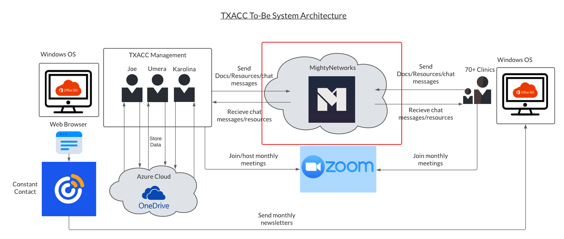

Page 43

## Sample Input/ Output Documents/ Sample Data from Cient [OPTIONAL]

This section is omitted since :

(1) The Resource Center will not generate any reports that require input from users. The parts that may need sample input/ output will be search functionality (User Story 8: search for resources and User Story 9: search for clinics) and validation for account registration/login/password requirements

(2) For account registration/login/password: Mighty Network has built-in validation for account and password sign-up/login. We will later create test cases and test this feature during Design and Construction phases.

(3) Similarly, the search functionality on the Resource Center will be an already built-in widget on Mighty Network that does not require any codes.

(4) Team has not gained access to TXACC’s current materials that will be uploaded to the Resource Center and thus, cannot create sample input and output for search functionality

## Prototype Iterations

We choose to use wireframes since this prototype method is high-resolution and easy to create while also helpful and effective in clarifying the project’s scope and ideas with our clients.

Link to UT Box: <https://utexas.app.box.com/folder/156075914108>

## Client Meeting Agendas

Link to UT Box: <https://utexas.box.com/s/zx6s6jg9m9icmbxt2ujhyatoff3a0sbl>

Page 44